Run the Python program and generate Article table (10000 articles), User table (10000 users), and Read table (1 million records). Be-Read table and Popular-Rank table need to be derived yourself.

Among the totally generated 10000 articles. Each article has a text file and 1-5 images. 5% of articles have a video each. In each article record, the attribute values of text, image, and video correspond to the filenames of text, image(s), and video, respectively, which are stored under the article directory

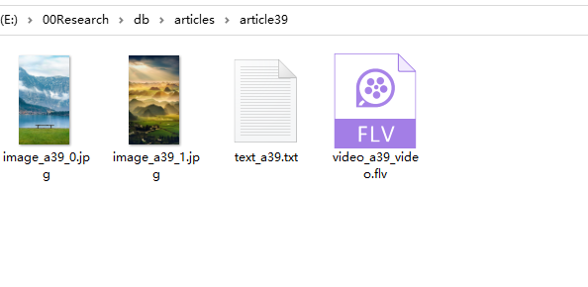

Three different sizes (10G, 50G, or 100G) of data can be generated after running the corresponding program locally.